LOGOS FOR STAND LABELLING
- Poland tastes good
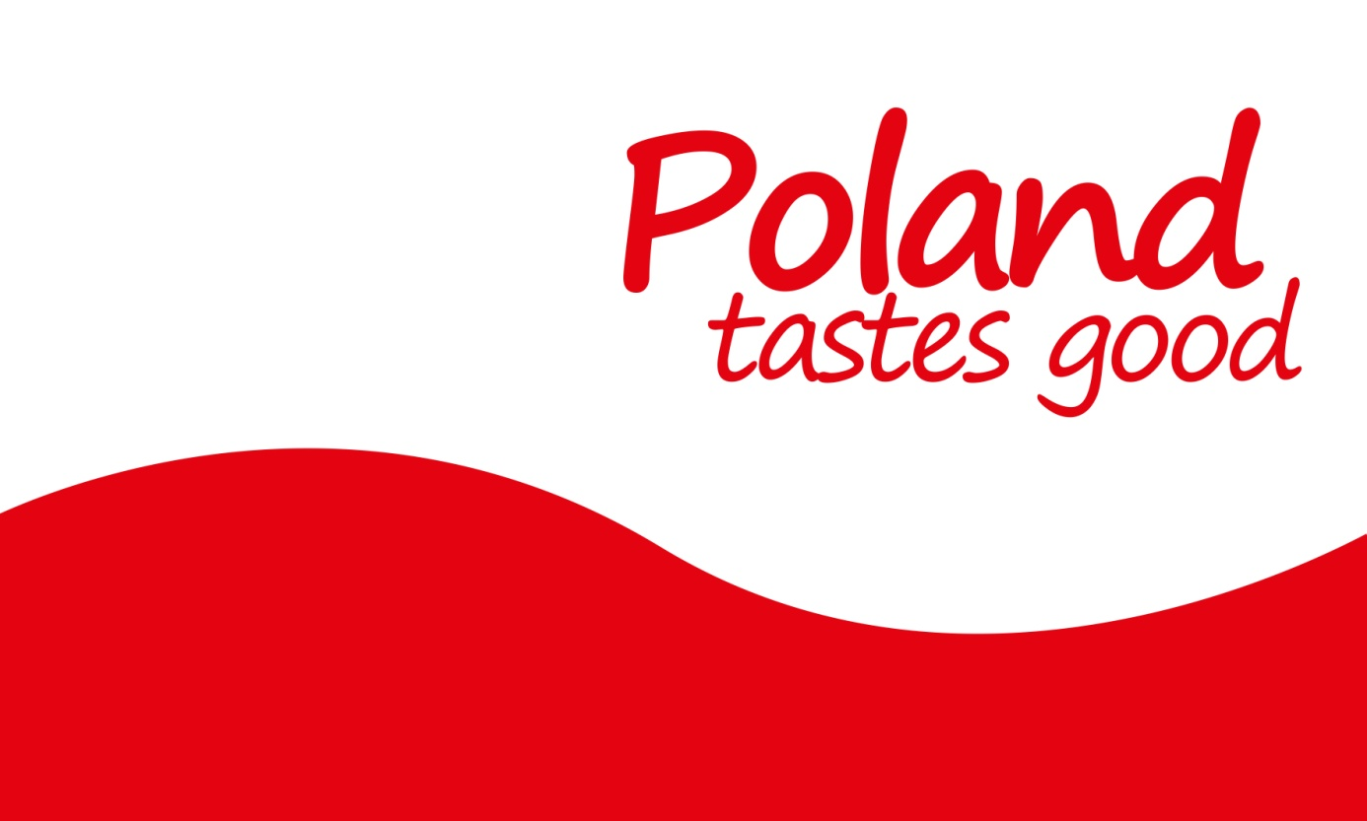
- National Association of Fruit and Vegetables Producer Groups
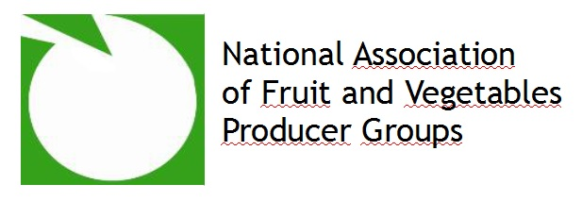
- Information on co-financing
